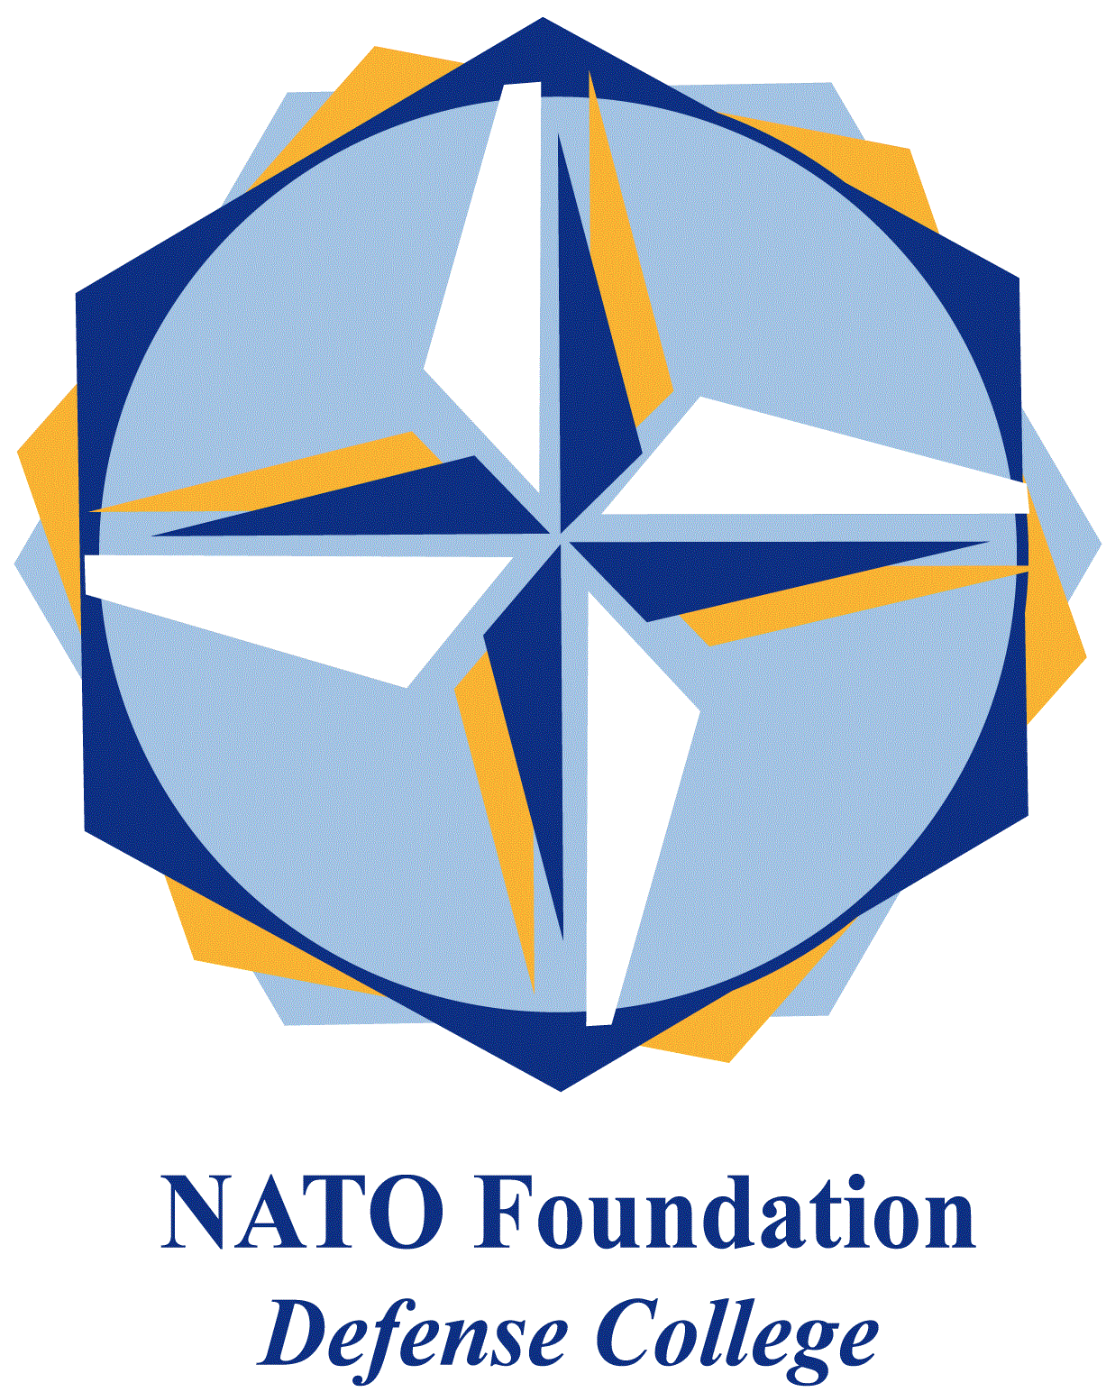
NATO DEFENSE COLLEGE FOUNDATION
STRATEGIC TRENDS
February 2016
GULF
Turkey’s military base in Qatar and the Sunni reactive alignment
Turkey will establish a permanent military base in Qatar (to include army, navy, air force and special forces); at least 3.000 Turkish militaries are going to be deployed. Ankara and Doha are in talks for the signature of a Status of Forces Agreement (SOFA) to frame Turkish military presence in the Al-Thani’s emirate. Turkey would be ready to conduct counter-piracy operations in the Indian Ocean, while the Qatari army would receive high-quality training from Ankara’s peers.
Through a defence hub in Qatar, Turkey will have the potential to enhance its military projection not only in the Middle Eastern region, but towards Central Asia too. Qatar, who already hosts United States’ Al-Udeid air base, pursues the differentiation of security alliances, although Washington remains the first, main GCC’s external security provider.
With such a long-term geostrategic choice, Turkey overtly aligns with the Sunni front led by Saudi Arabia, thus contributing to a further strategic polarisation in the area. Ankara has just made available to Saudis the Incirlik base to carry out strikes against the so-called Islamic State in Syria (stopped when Riyadh started to target Shia militias in Yemen). Turkish and Saudis armed forces have been conducting joint air defence exercises in Konya (central Turkey).
Turkey and Saudi Arabia envisaged to deploy special forces (together with Qatar and the UAE) for an hypothetical US-led ground operation in Syria against the “caliphate”: a scenario that would escalate regional violence. Moreover, such a military commitment would expose them may overstretch these regional powers and expose them to further jihadi attacks at home.
On the one hand Riyadh is stuck in the “Yemeni quagmire” (now called Operation Restoring Hope, still undecided between a scaling back and a new decisive battle for Sa’ana); on the other hand Ankara fights against Kurdish militias between Iraq (PKK) and Syria (YPG), in addition to tackling social upheavals in Eastern Anatolia. For these reasons, the announcement of a “Syrian operation” can be firstly read as a diplomatic message to Washington, aimed at demonstrating that the Sunnis will really fight “IS”, urging the Americans, at the same time, to stand by them to parry and weaken the Russian-Iranian axis.
Turkey, the GCC (and to some extent Israel) have so far underbalanced Iran, due to the influence of their differing political regimes on mutual geopolitical interests. But Russia’s military intervention in support of Bashar Al-Assad regime has been a real game-changer, able to put together a reactive Sunni alignment vìs-a-vìs the Damascus-Teheran-Baghdad front.
To this purpose, Qatar has played a key-role of bridge between Turkey and Saudi Arabia. In this Middle East deeply polarised along sectarian lines, Doha now recognizes that it can act successfully only by avoiding direct confrontation with Saudi’s interests, while Riyadh needs Qatar’s mediator skills in order to build regional alliances in times of crisis.
The traditional trade-off between energy and security still persists in the Gulf: due to the diplomatic rift with Russia, Turkey looks for GCC and Qatar’s natural gas supply, as it is attempting to normalise relations with Israel (with an eye to the East-Med pipeline).

